1.SELECT SUBJECTNAME FROM Subject2063 WHERE SEMESTER IN 'SEM5';

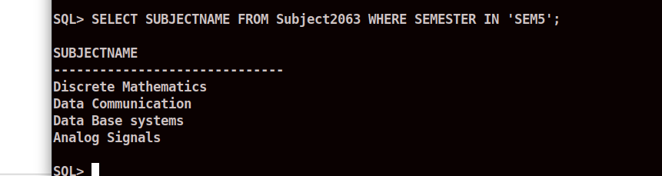

2.SELECT ROLLNO FROM Result2063 WHERE MARKS>61 AND MARKS<70 AND SUB_CODE='CS501';
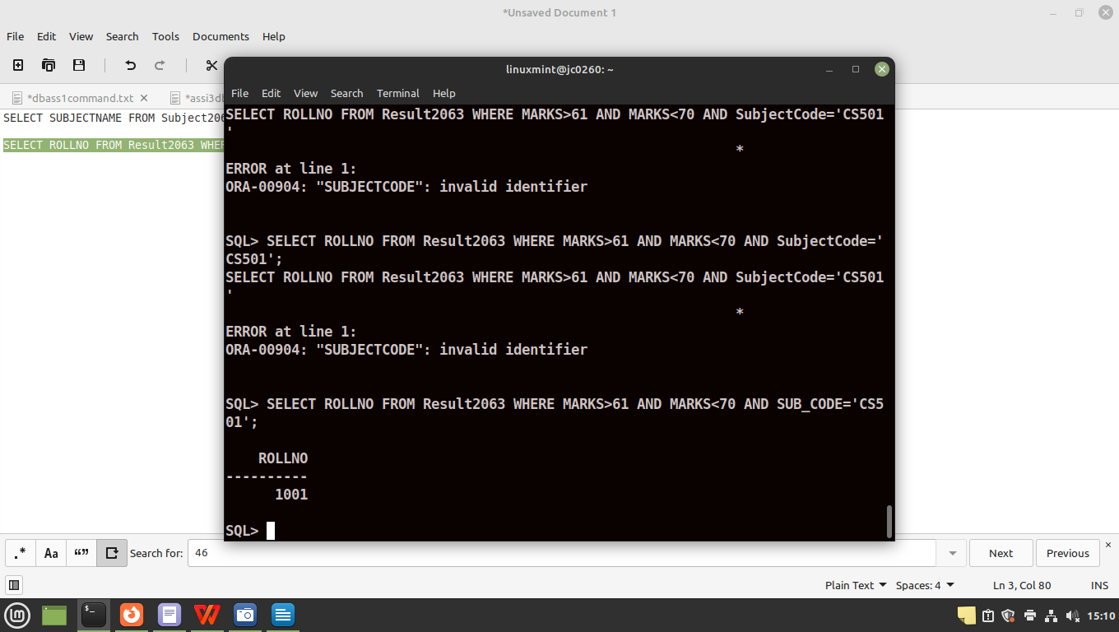

3. UPDATE STUDENT2063 SET ADDRESS='VIP Road kolkata' WHERE ROLLNO=2001;
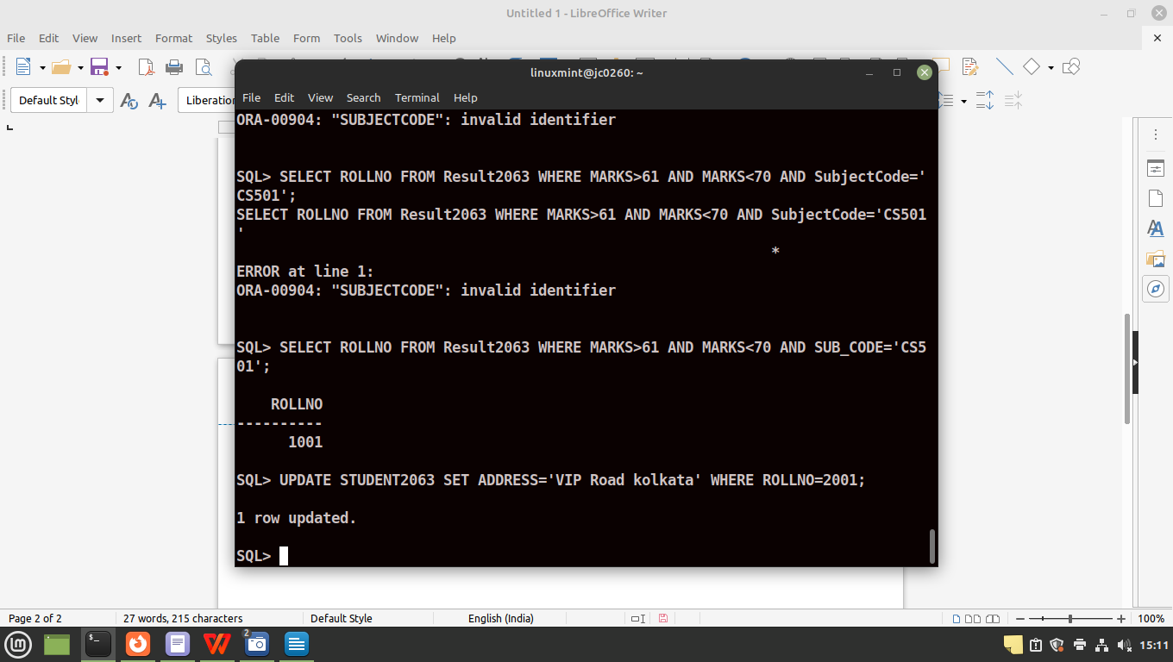

4. UPDATE DEPARTMENT2063 SET StudentAlloted=75 WHERE DEPTCODE='IT';
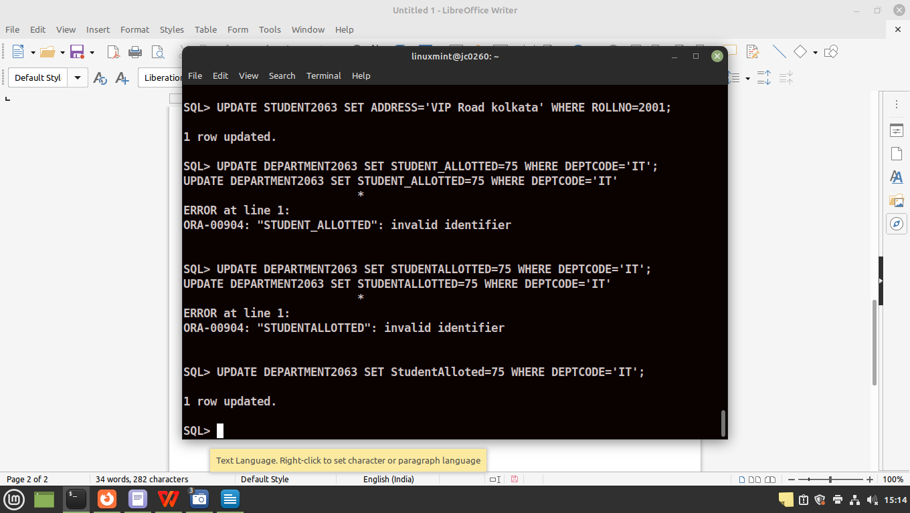

5. UPDATE DEPARTMENT2063 SET StudentAlloted=StudentAlloted + 15 WHERE DEPTCODE='CSE';

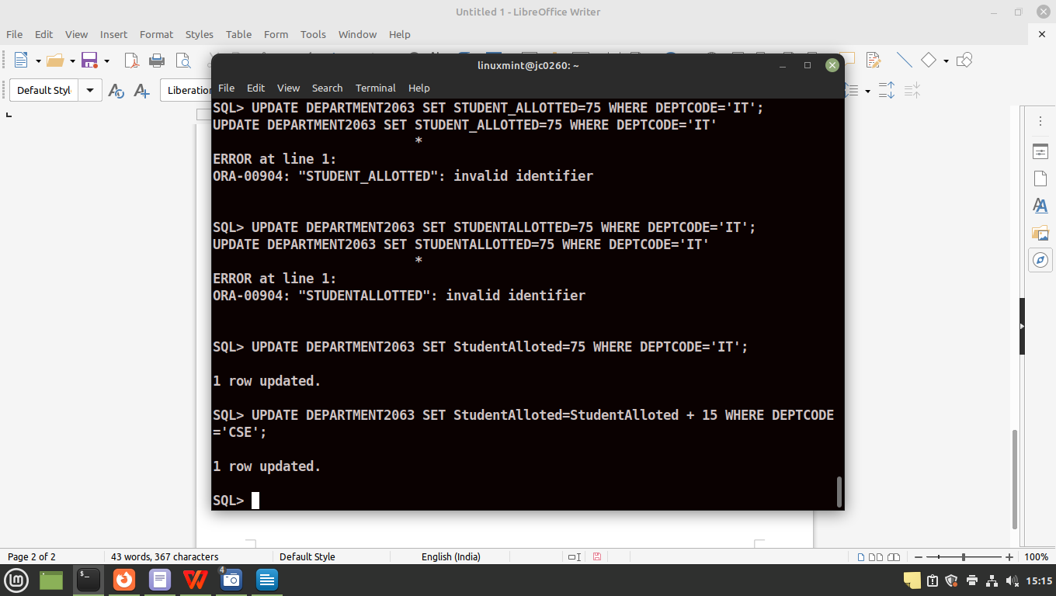

6. UPDATE RESULT2063 SET MARKS=MARKS + 5 WHERE SUB_CODE='CS302';
(SELECT * FROM RESULT2063 WHERE SUB_CODE='CS302';)
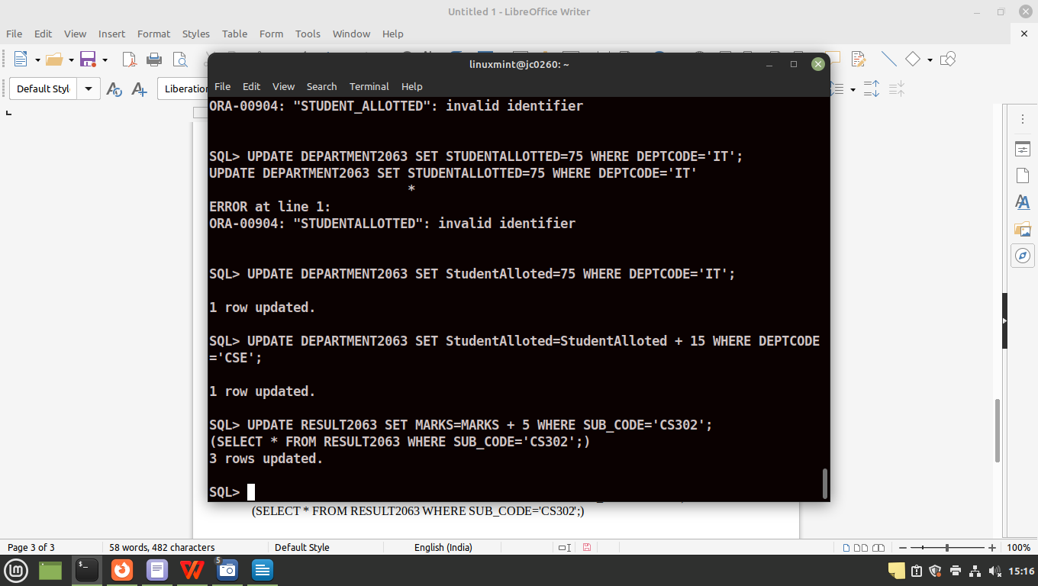

7. UPDATE STUDENT2063 SET PHONENO=8910793249 WHERE DEPTCODE='CSE' AND SEMESTER='SEM5' AND PHONENO IS NULL;
(SELECT * FROM STUDENT2063 WHERE PHONENO=8910793249;)

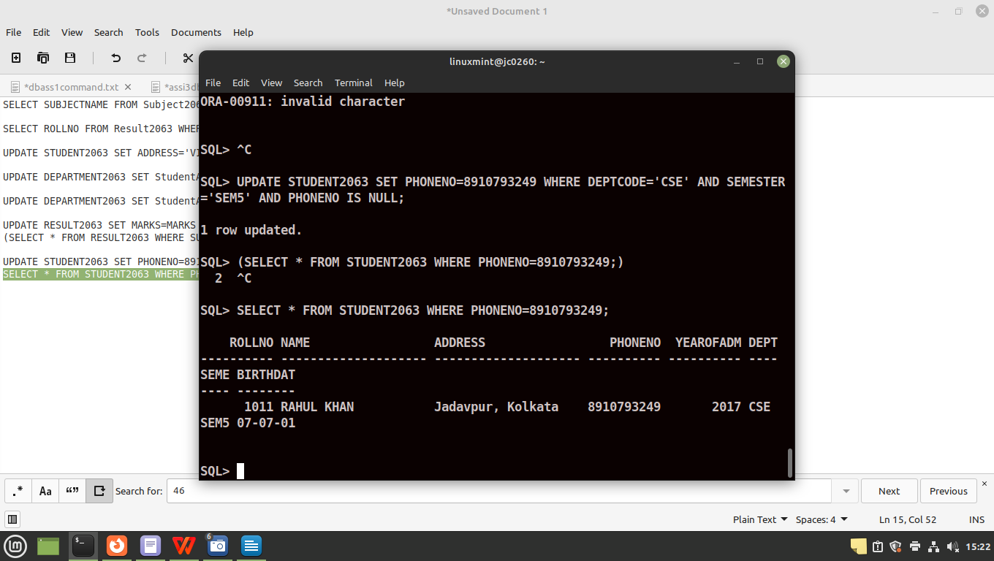
8. SELECT * FROM RESULT2063 WHERE MARKS < PASSMARKS;
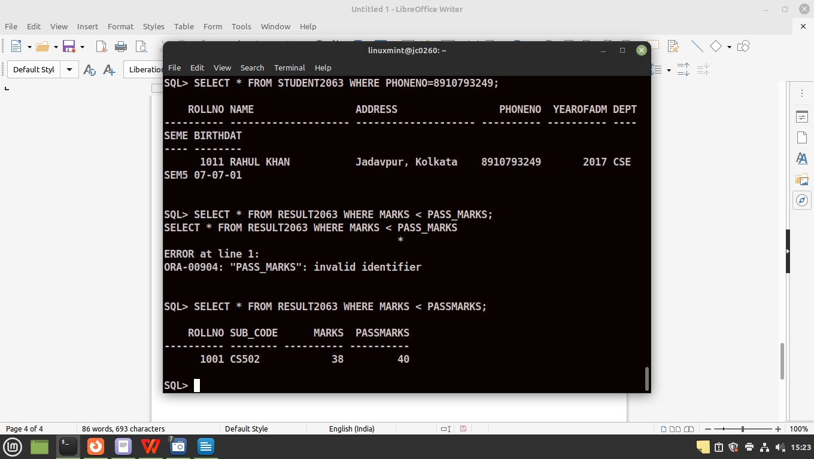

9. UPDATE RESULT2063 SET MARKS=MARKS+2 WHERE MARKS < PASSMARKS AND PASSMARKS-MARKS >= 2 AND SUB_CODE LIKE 'CS%';
SELECT * FROM RESULT2063 WHERE ROLLNO=1001 AND SUB_CODE='CS502';

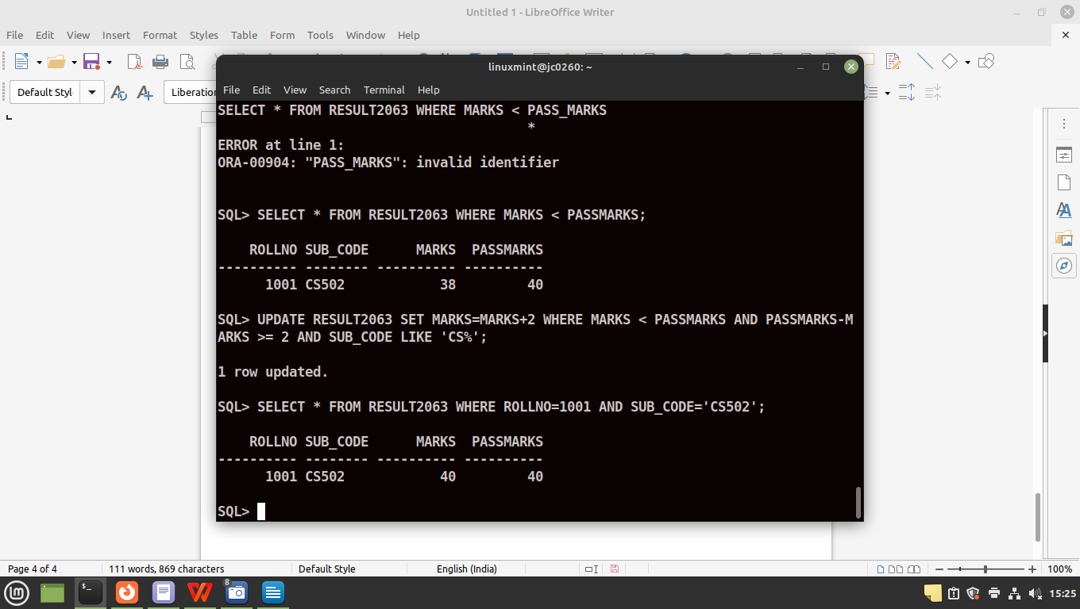

10. SELECT * FROM STUDENT2063 WHERE ROLLNO = 3005;
DELETE FROM STUDENT2063 WHERE ROLLNO = 3005;
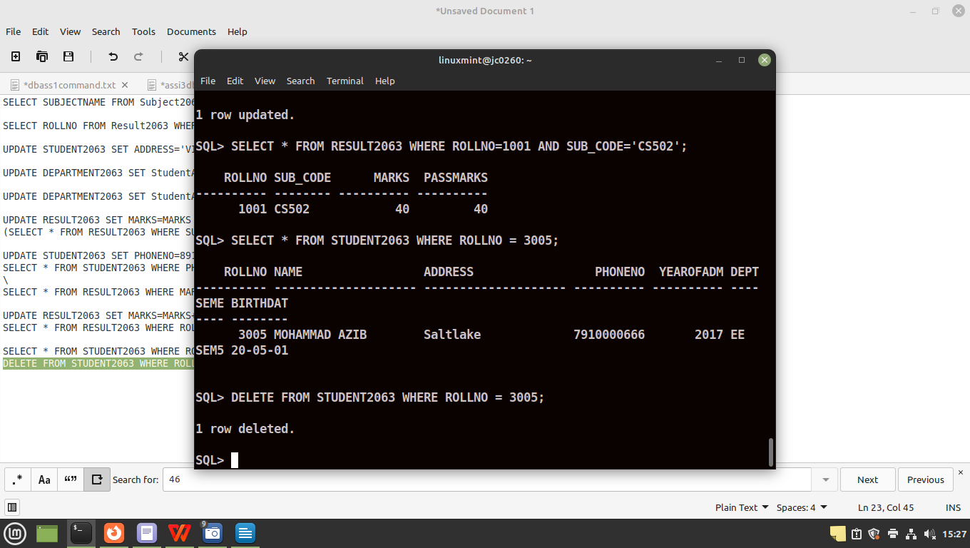

11. SELECT NAME,DEPTCODE,SEMESTER FROM STUDENT2063 WHERE YEAROFADM < 2017 ORDER BY NAME ASC;

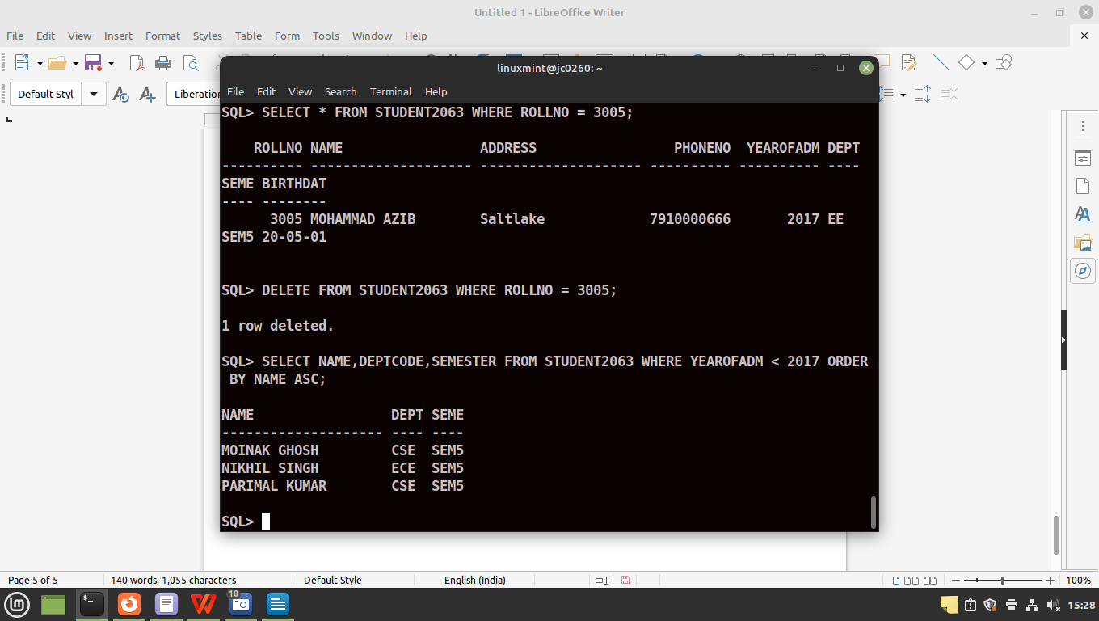
12. SELECT ROLLNO,SUB_CODE FROM RESULT2063 WHERE (SUB_CODE='CS301' OR SUB_CODE='CS302') AND MARKS > 90;

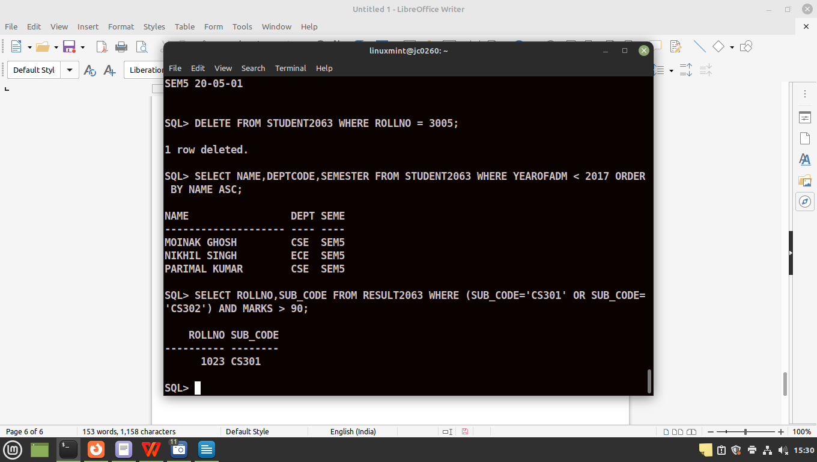

13. INSERT INTO STUDENT2063 VALUES (3005,'MOHAMMAD AZIB','Saltlake',7910000666,2017,'EE','SEM5',TO_DATE('20-05-2001','DD-MM-YYYY'));
SELECT * FROM STUDENT2063 WHERE NAME= 'MOHAMMAD AZIB';

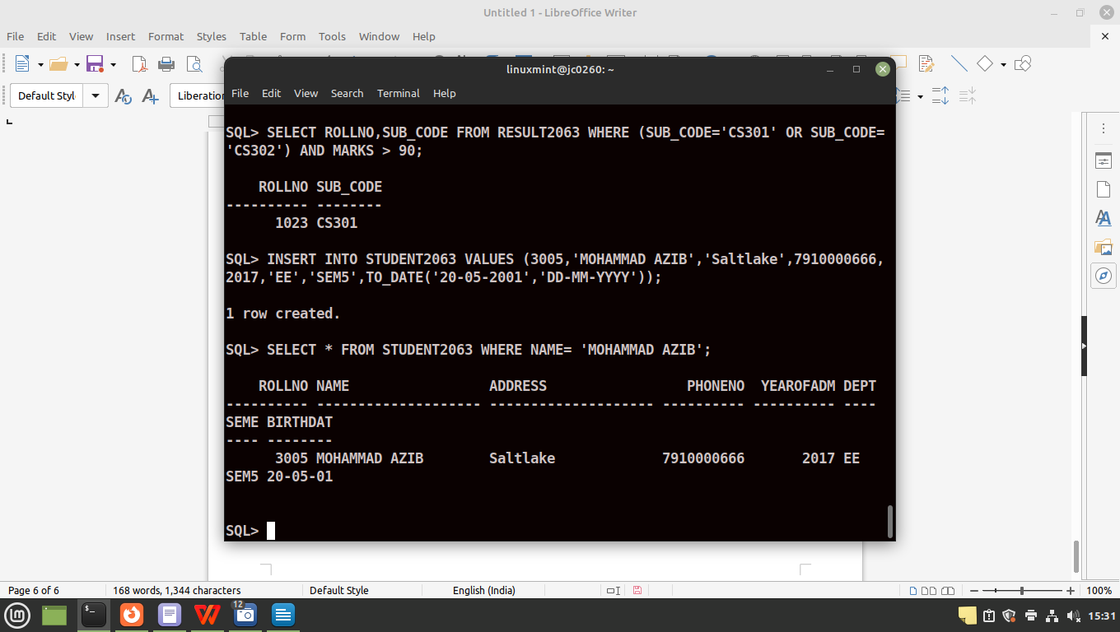

13. INSERT INTO STUDENT2063 VALUES (3055,'UDITA SINHA','Kaikhali',9470020048,2021,'CSE','SEM5',TO_DATE('25-01-2003','DD-MM-YYYY'));
SELECT * FROM STUDENT2063 WHERE NAME= 'UDITA SINHA';
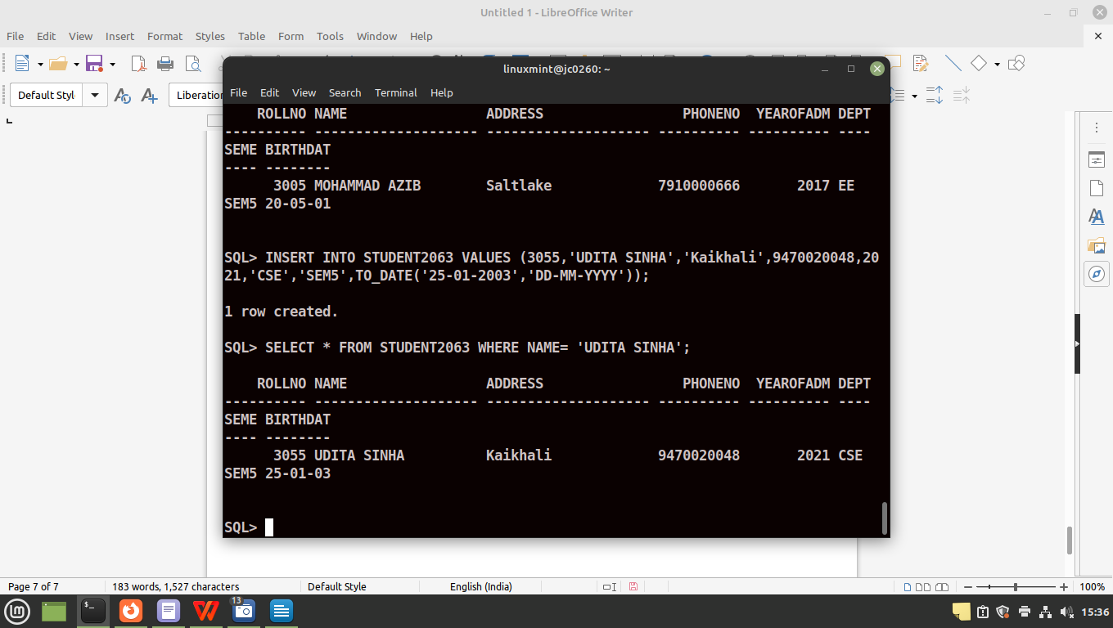

14.UPDATE STUDENT2063 SET PHONENO = NULL WHERE NAME='UDITA SINHA';
SELECT * FROM STUDENT2063 WHERE NAME= 'UDITA SINHA';

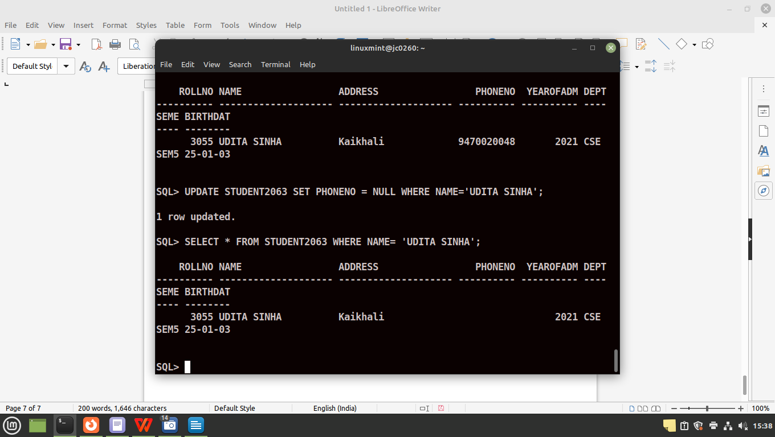

15. SELECT ROLLNO,SUB_CODE FROM RESULT2063 WHERE MARKS > (40 + PASSMARKS) AND SUB_CODE='CS501' OR SUB_CODE='CS502';
